**OpenSap Python Course**

**Week 1:-**

**Self test 1:-**

Q1)What are advantages of choosing Python for programming?

Ans:- a) Python is easy to learn

b) Python is used in industry, for example in the fied of machine learning

c) Pyhton is popular, so you can find lots of information about it on the internet.

Q2) What is the result of the following operation 9 / 4?

Ans:- 2.25

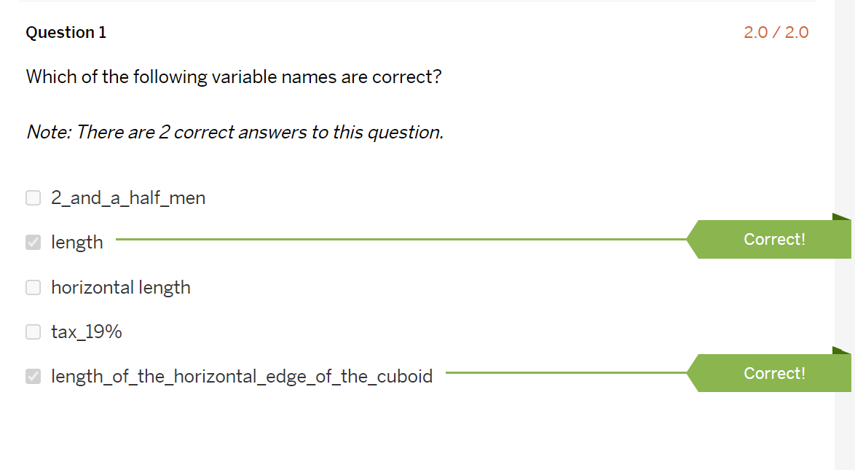Self test 2:-

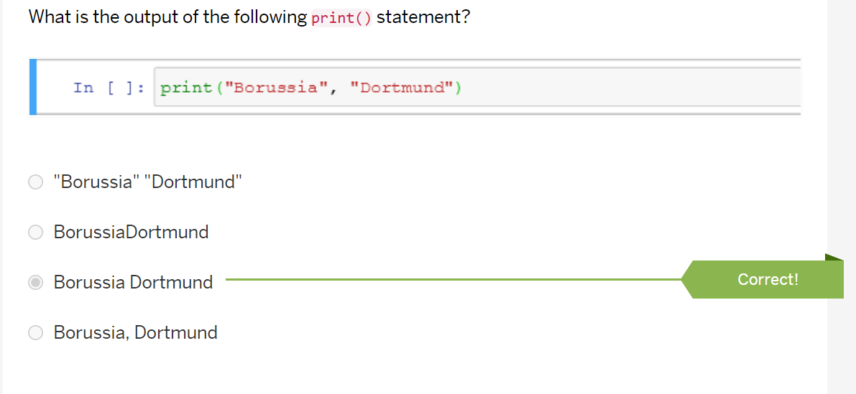Self test 3:-

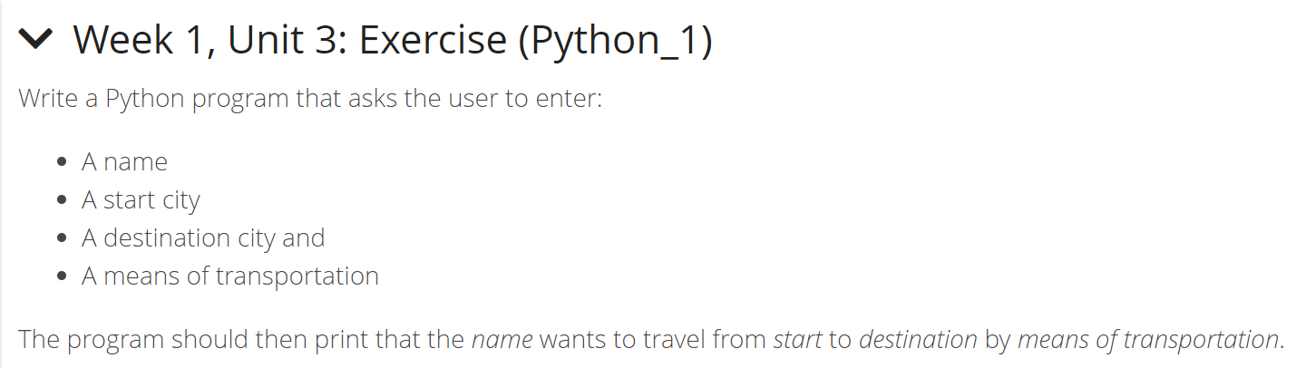Unit 3 Exercise:-

Ans:-

name = input("Please enter your name: ")

start1 = input("Please enter a start: ")

end1 = input("Please enter a destination: ")

mode1 = input("Please enter a meas of transportation: ")

print(name, "wants to travel from", start1, "to", end1, "by", mode1)

Self test 4:-

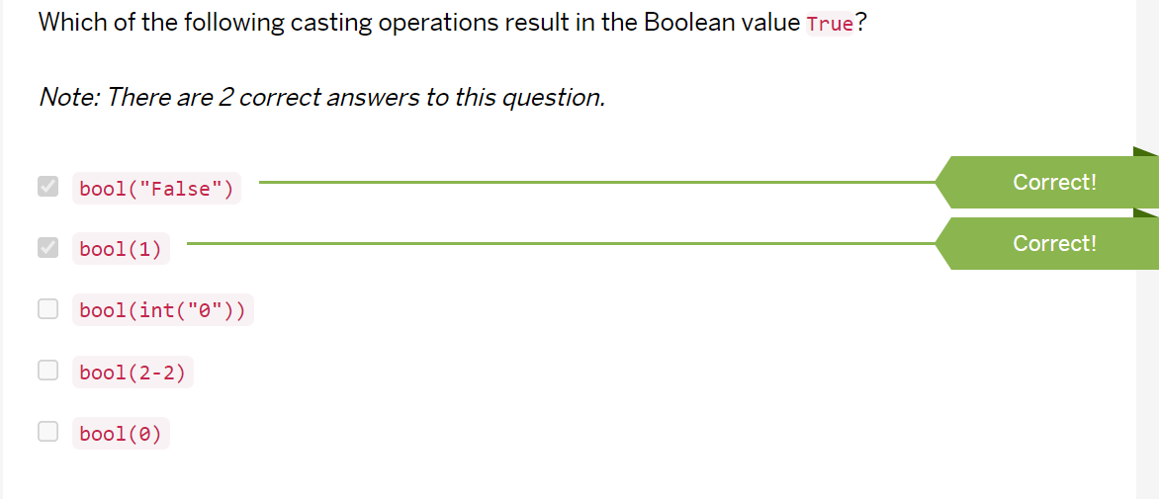

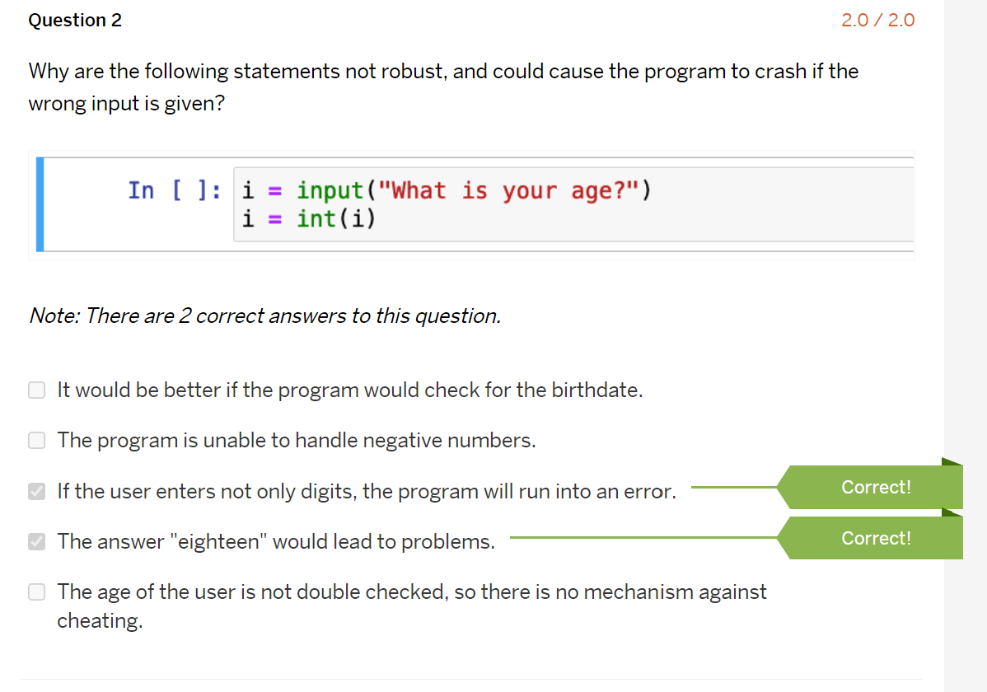

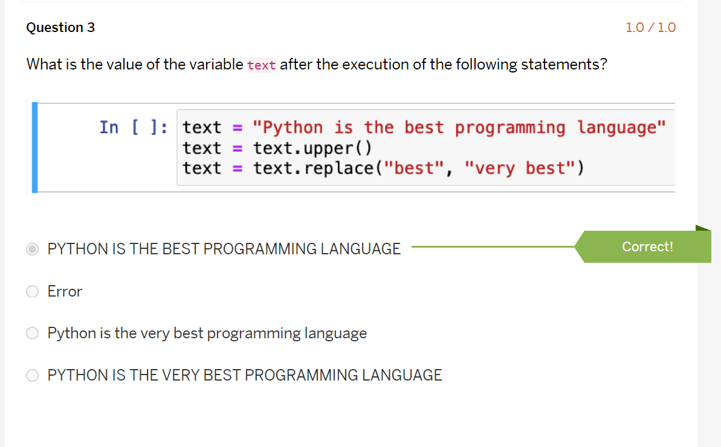

Self test 5

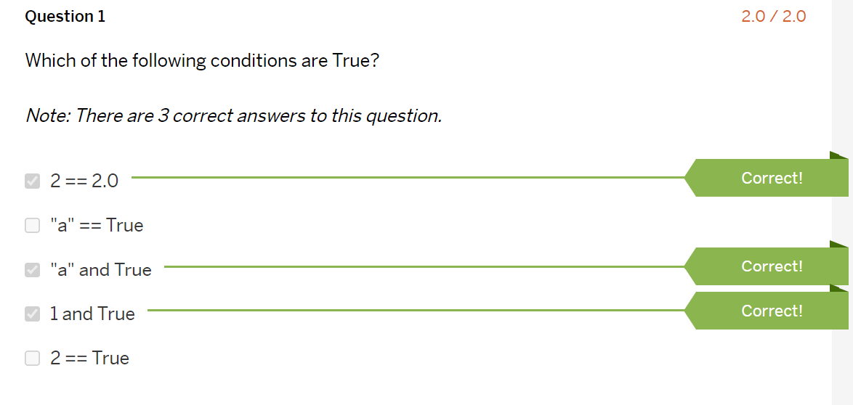

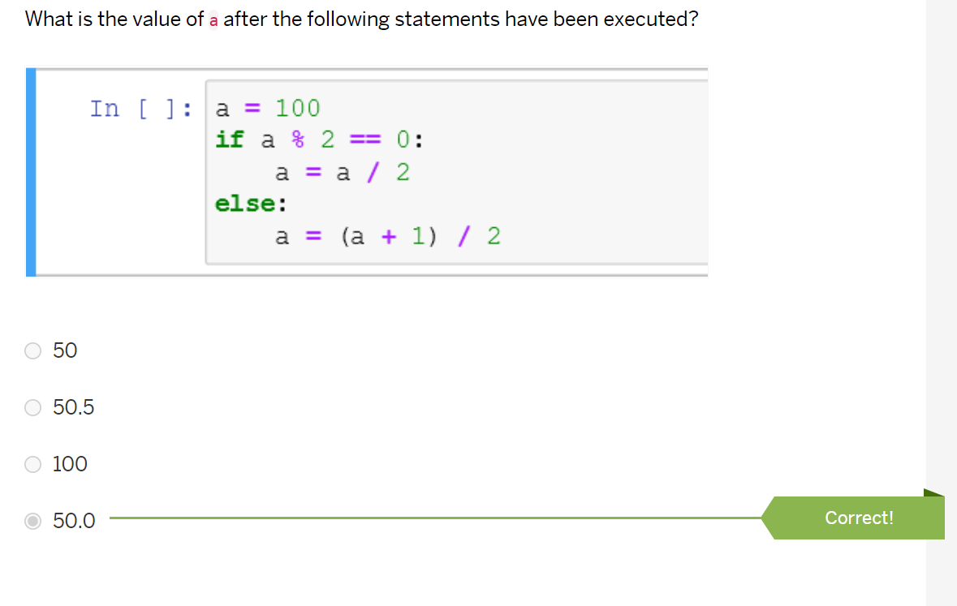

Unit 5: Exercise (Python_1):-

Write a Python program that asks the user to enter three integer numbers. The program should output the largest of the three numbers.

num1 = int(input("Enter first number: "))

num2 = int(input("Enter second number: "))

num3 = int(input("Enter third number: "))

if (num1 > num2) and (num1 > num3):

largest = num1

elif (num2 > num1) and (num2 > num3):

largest = num2

else:

largest = num3

print("The largest number is",largest)

Slef test 6:

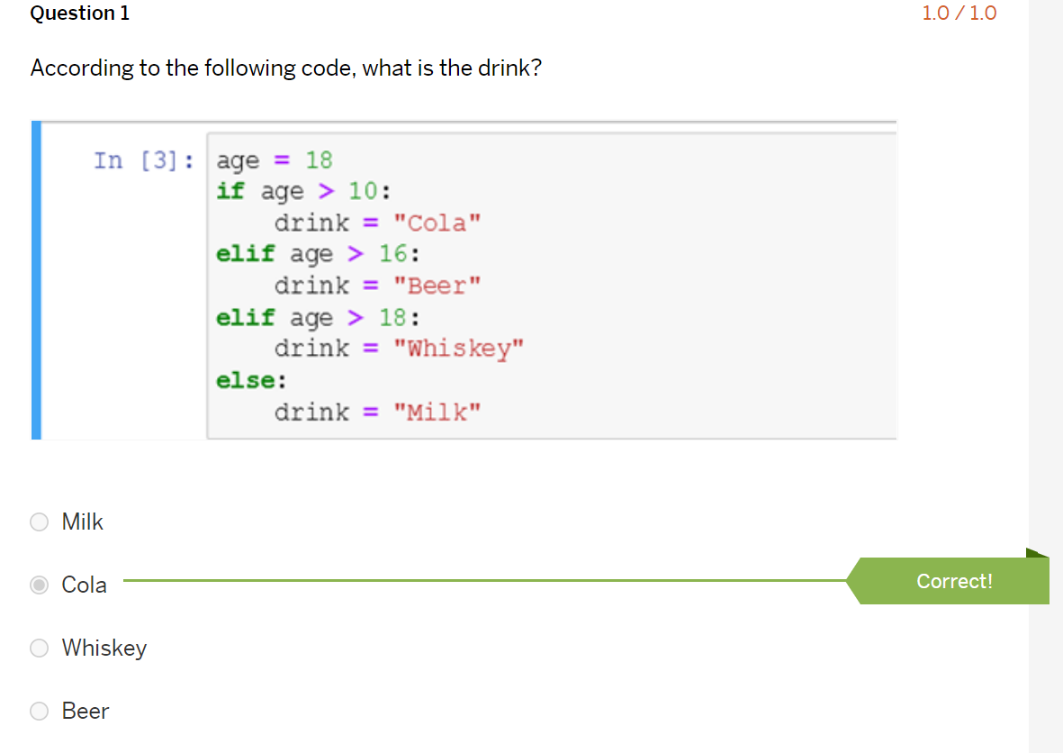

Self-test 7:

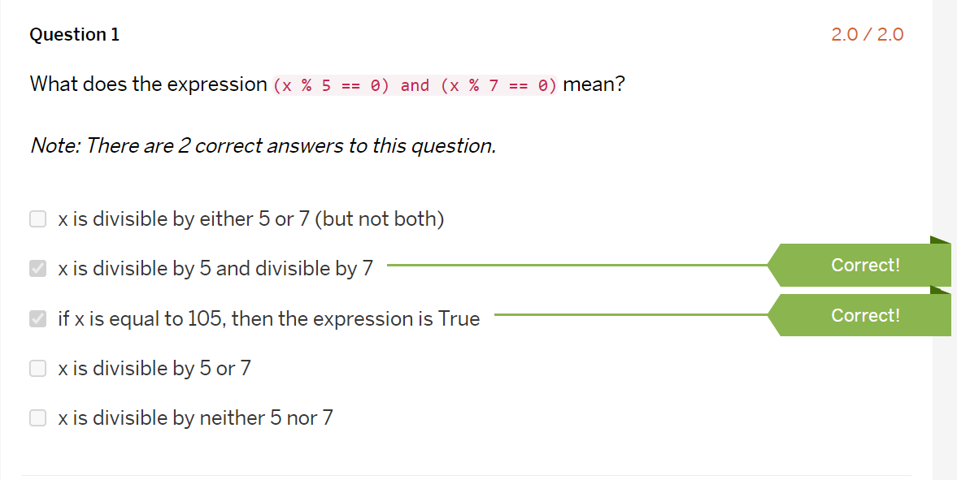

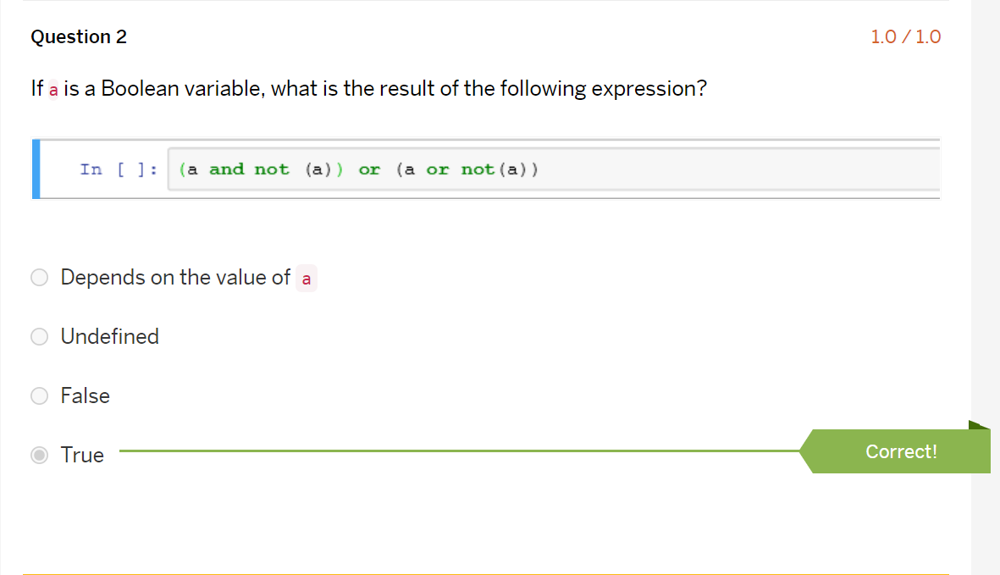

Assignment Week 1 (Part 2 - Exercise):-

Write a program that asks the user for the values of three angles in degrees. First check if the entered values are valid. The values are only valid if they are >0 and if their sum is 180°. If the entered values are valid, classify the triangle as right, acute or obtuse.

Ans:-

a = int(input())

b = int(input())

c = int(input())

if(a+b+c == 180 and a>0 and b>0 and c>0):

if(a == 90 or b == 90 or c == 90):

print("The triangle is a right angled triangle.")

elif(a > 90 or b > 90 or c > 90):

print("The triangle is obtuse angled triangle.")

else:

print("The triangle is acute angled triangle.")

else:

print("The entered value are not valid")

Bonus Exercise Week 1:-

Write a program that asks the user for the numbers a, b and c. The program should then print out how many solutions the quadratic equation has.

Ans:-

a = int(input())

b = int(input())

c = int(input())

ans = (b*b) - 4*a*c

if(ans == 0):

print("he quadratic equation has exactly one real solution.")

elif(ans > 0):

print("The quadratic equation has two real solutions.")

else:

print("The quadratic equation has two complex solutions.")

Week 2:-

Slef test 1:-

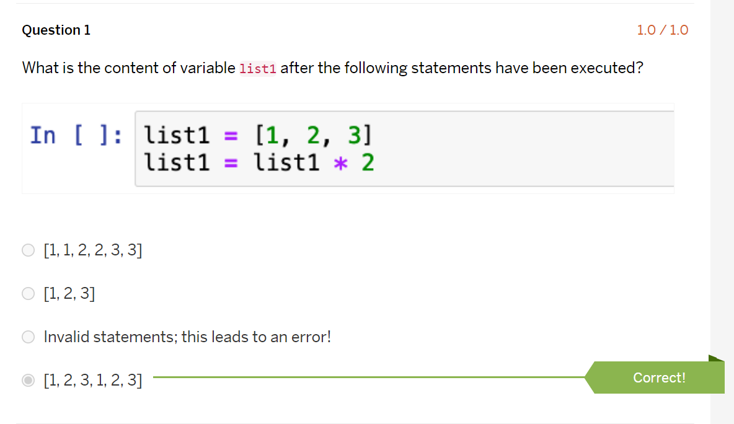

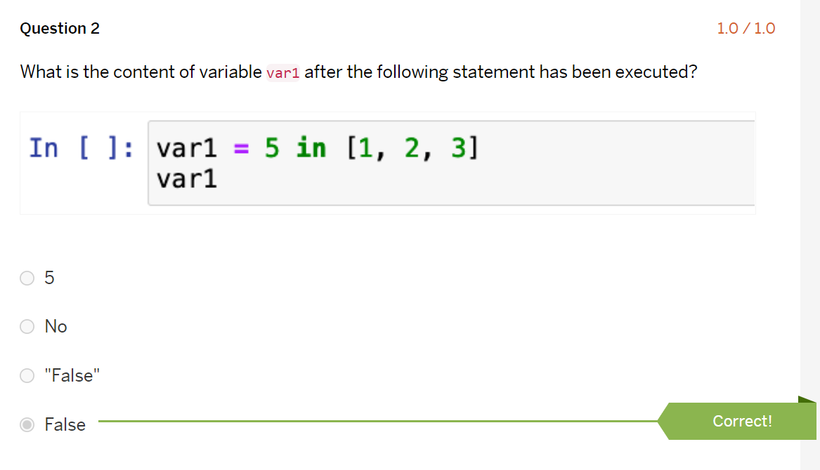

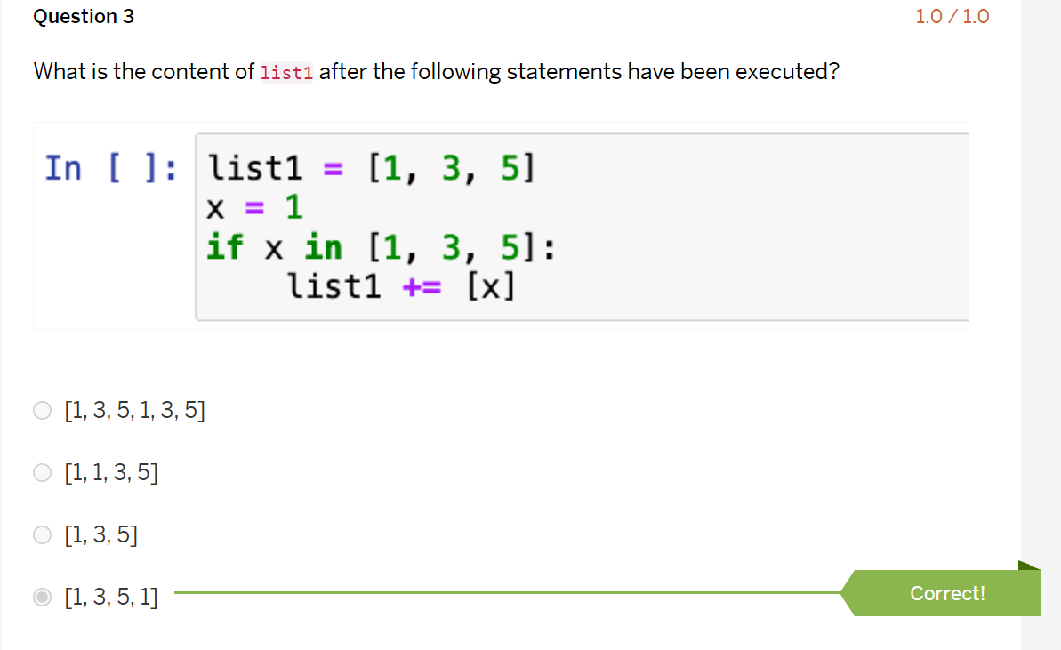

Self test 2:-

